**实验1：单臂路由+静态路由+DHCP**

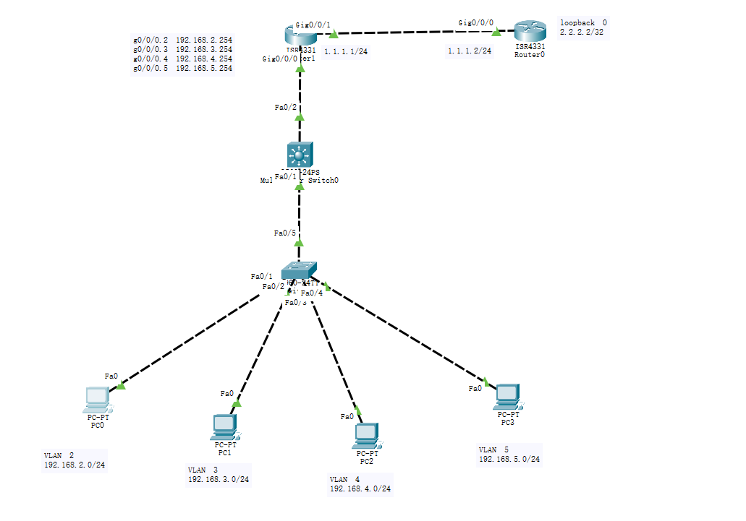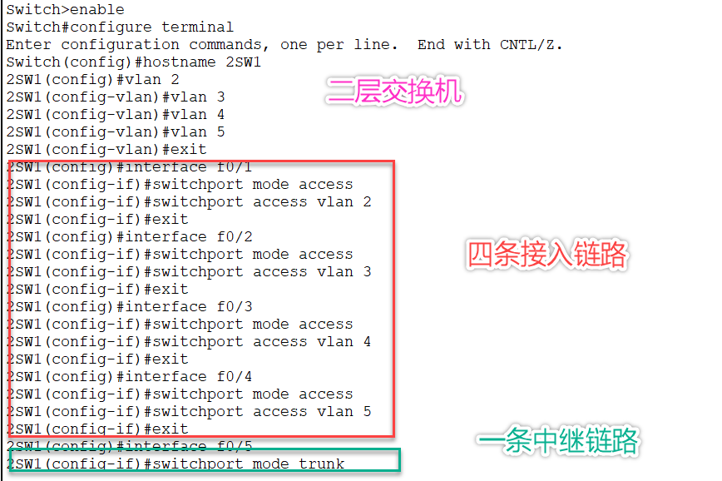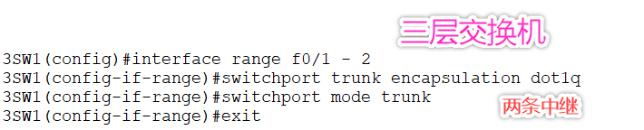

**R1路由器**：

**Enable 特权模式**

**Configure terminal 全局模式**

**Hostname R1 重命名R1**

**Interface g0/0/0 进入g0/0/0接口**

**No shutdown 开启接口**

**Exit 退出**

**Interface g0/0/0.2 进入g0/0/0.2子接口**

**Encapsulation dot1q 2 将vlan2 封装成802.1q**

**Ip address 192.168.2.254 255.255.255.0 设置子接口IP**

**Exit 退出**

**Interface g0/0/0.3 进入g0/0/0.3子接口**

**Encapsulation dot1q 3 将vlan3 封装成802.1q**

**Ip address 192.168.3.254 255.255.255.0 设置子接口IP**

**No shutdown 激活端口**

**Exit 退出**

**Interface g0/0/0.4 进入g0/0/0.4的子接口**

**Encapsulation dot1q 4 将vlan4 封装成802.1q**

**Ip address 192.168.4.254 255.255.255.0 设置子接口IP**

**No shutdown 激活端口**

**Exit 退出**

**Interface g0/0/0.5 进入g0/0/0.5的子接口**

**Encapsulation dot1q 5 将vlan 5封装成802.1q**

**Ip address 192.168.5.254 255.255.255.0 设置子接口IP**

**No shutdown 激活端口**

**Exit 退出**

**Interface g0/0/1 进入g0/0/1的接口**

**Ip address 1.1.1.1 255.255.255.0 设置接口IP**

**No shutdown 激活端口**

**Ip dhcp pool vlan2 定义vlan2的地址池**

**Network 192.168.2.0 255.255.255.0 宣告的网段192.168.2.0**

**Default-router 192.168.2.254 网关192.168.2.254**

**Dns-server 114.114.114.114 dns服务器的地址**

**Exit 退出**

**Ip dhcp pool vlan3 定义vlan3的地址池**

**Network 192.168.3.0 255.255.255.0 宣告的网段192.168.3.0**

**Default-router 192.168.3.254 网关192.168.3.254**

**Dns-server 114.114.114.114 dns服务器的地址**

**Exit 退出**

**Ip dhcp pool vlan4 定义vlan4的地址池**

**Network 192.168.4.0 255.255.255.0 宣告的网段**

**Default-router 192.168.4.254 网关地址**

**Dns-server 8.8.8.8 dns服务器的地址**

**Exit 退出**

**Ip dhcp pool vlan5 定义vlan5的地址池**

**Network 192.168.5.0 255.255.255.0 宣告的网段**

**Default-router 192.168.2.254 网关地址**

**Dns-server 114.114.114.114 dns服务器的地址**

**Exit 退出**

**Ip route 0.0.0.0 0.0.0.0 1.1.1.2 默认路由指向R2**

**R2 路由器**

**Enable**

**Configure terminal**

**Hostname R2**

**Interface f0/0/0**

**Ip address 1.1.1.2 255.255.255.0**

**No shutdown**

**Exit**

**Interface loopback 0**

**Ip address 2.2.2.2 255.255.255.255**

**No shutdown**

**Exit**

**Ip route 192.168.2.0 255.255.255.0 1.1.1.1**

**Ip route 192.168.3.0 255.255.255.0 1.1.1.1**

**Ip route 192.168.4.0 255.255.255.0 1.1.1.1**

**Ip route 192.168.5.0 255.255.255.0 1.1.1.1**

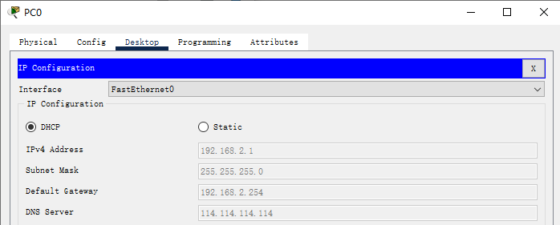

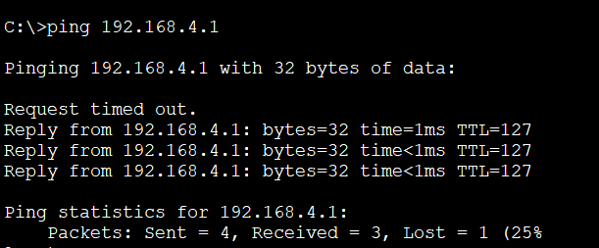

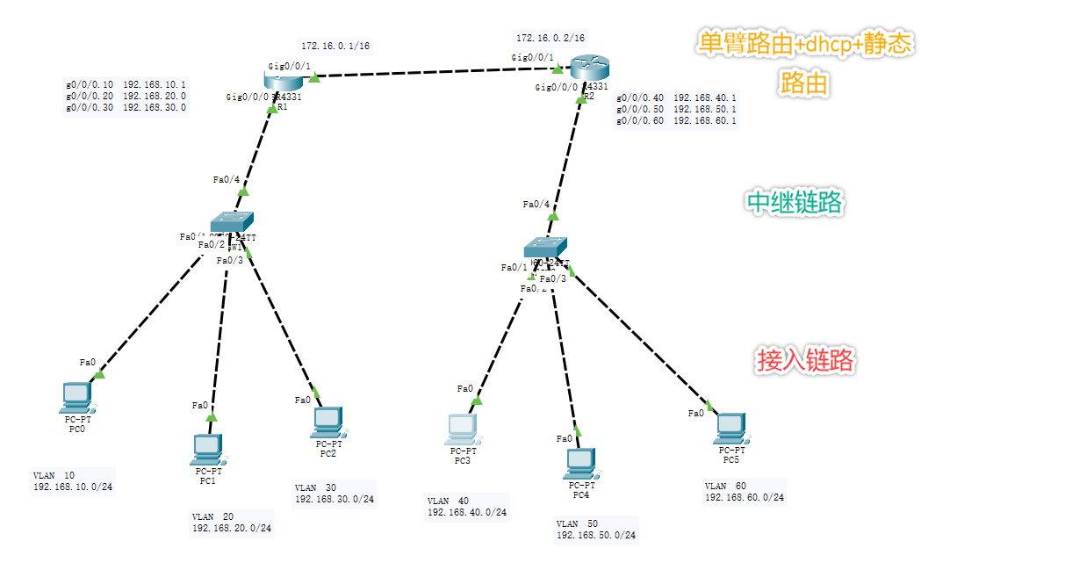

**实验2：配置STP(生成树)**

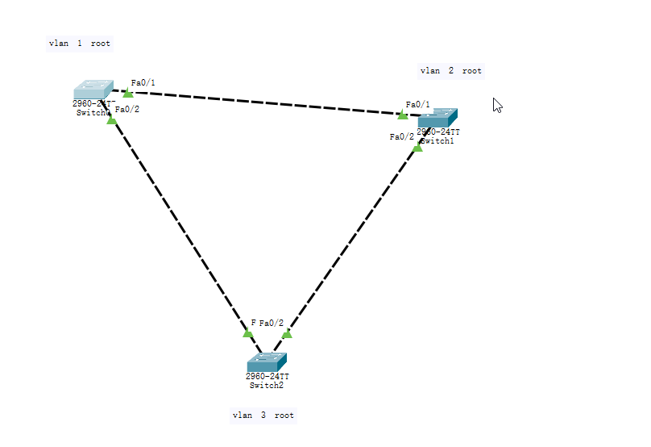

**//设置vlan 1是根网桥**

**SW1(config)#spanning-tree vlan 1 root primary**

**//设置vlan 2和vlan 3不是根网桥**

**SW1(config)#spanning-tree vlan 2-3 root secondary**

**//查看生成树**

**SW1#show spanning-tree**

**VLAN0001**

**Spanning tree enabled protocol ieee**

**Root ID Priority 24577**

**Address 0007.EC8C.A7B1**

**This bridge is the root //这是根网桥**